So far:

Expressions

Statements

Flow of control

Loop

**The Most important thing Functions**

* Effective programming requires problem decomposition into manageable pieces

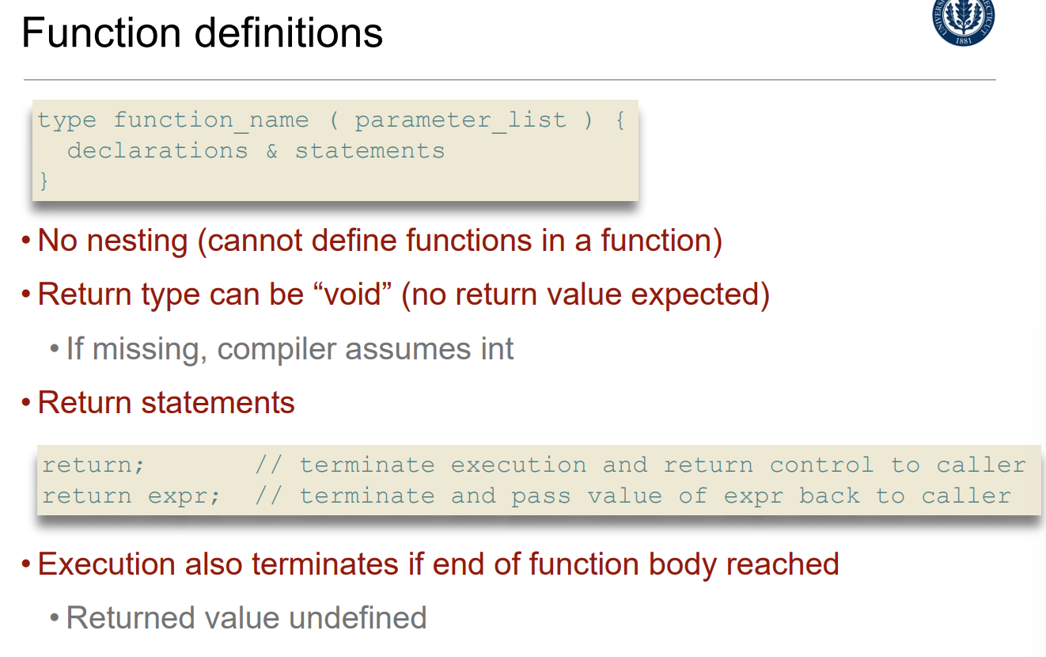

Functions can be defined in any order

Declare a function before first use if definition comes later

Function prototypes often placed in header files (and reused)

Functions can declare local variables

Parameters and local variables can only be accessed inside the function

Storage class “auto” by default, i.e., discarded when function returns

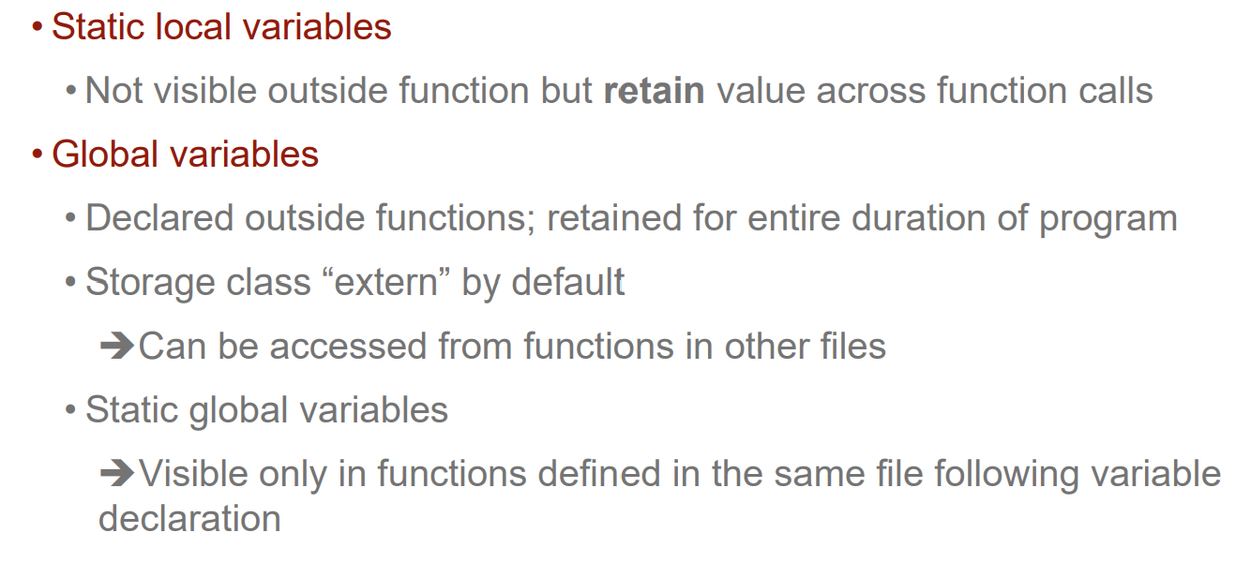

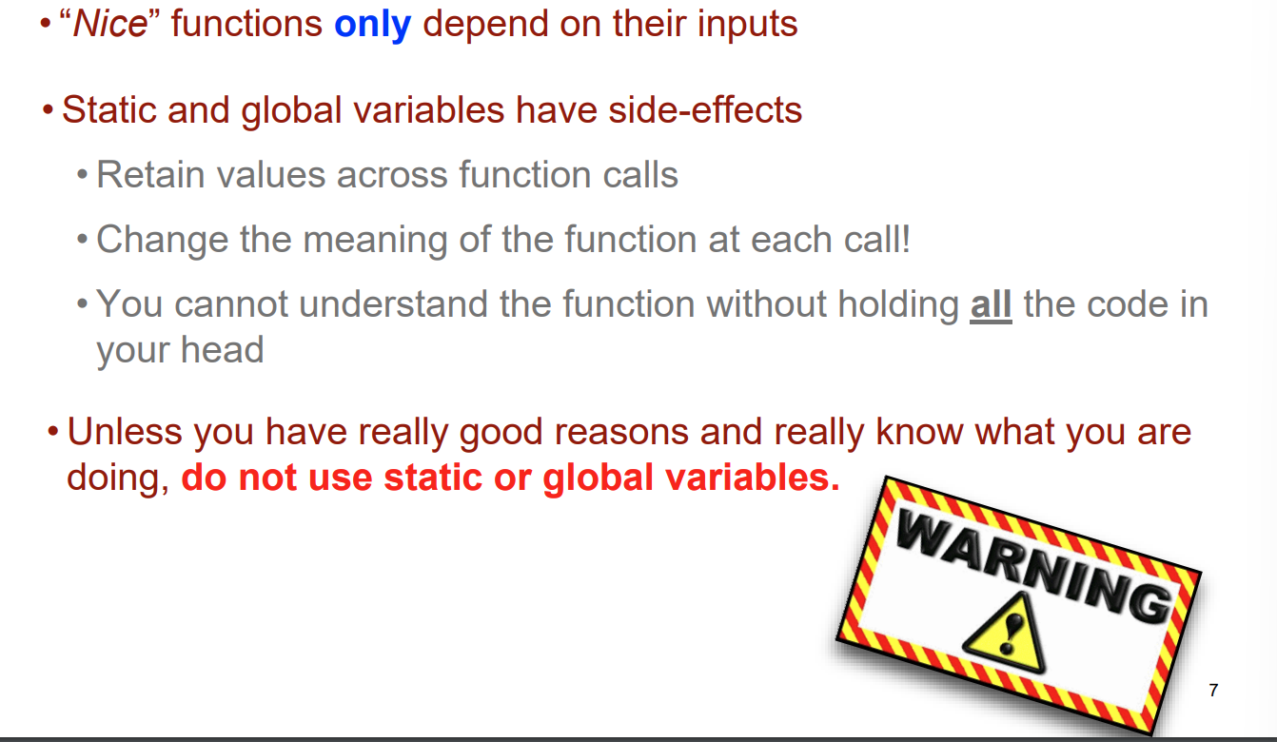

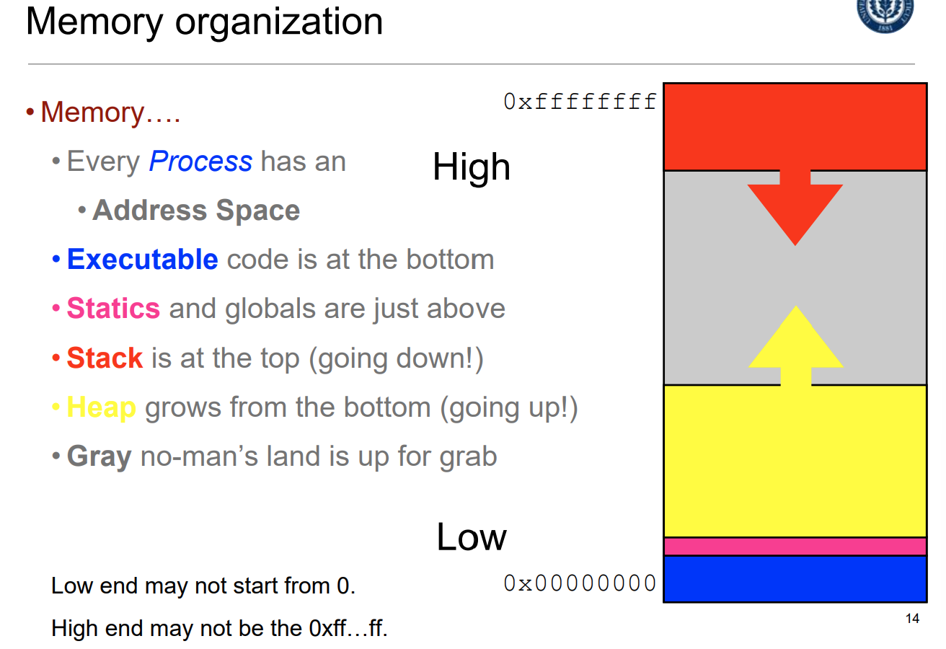

Recursion yay!

Can be used with new functions

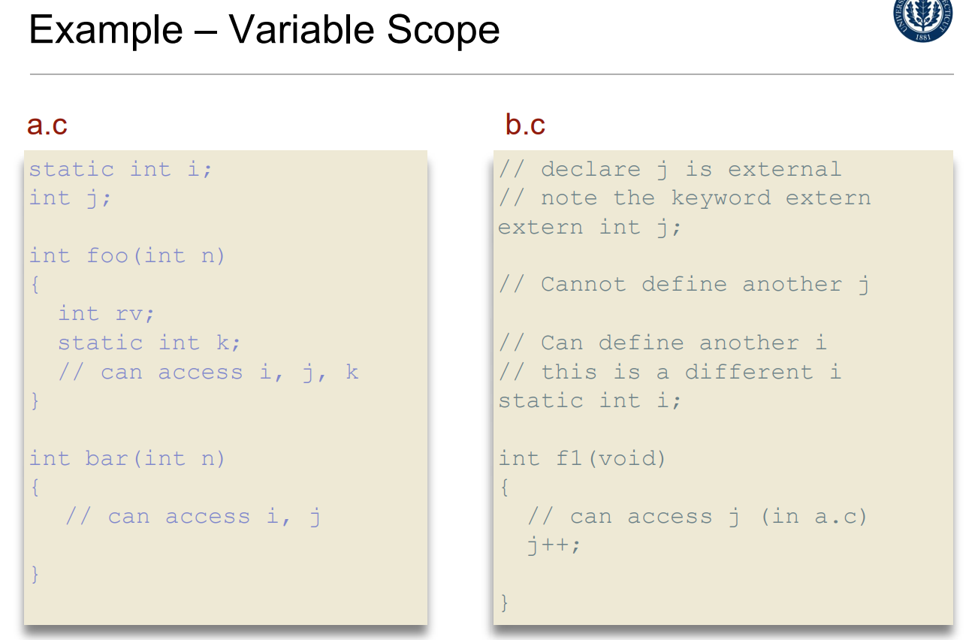

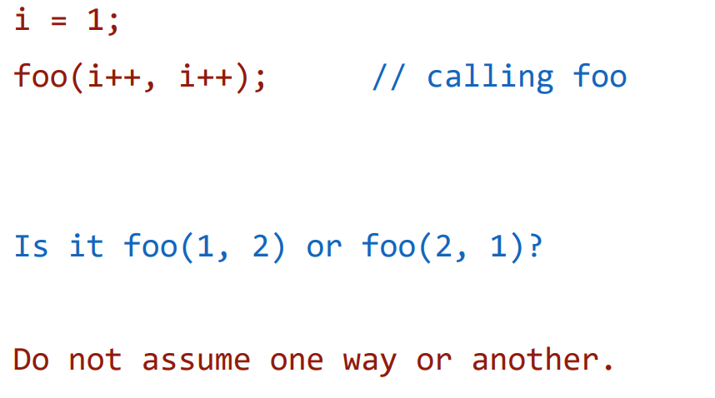

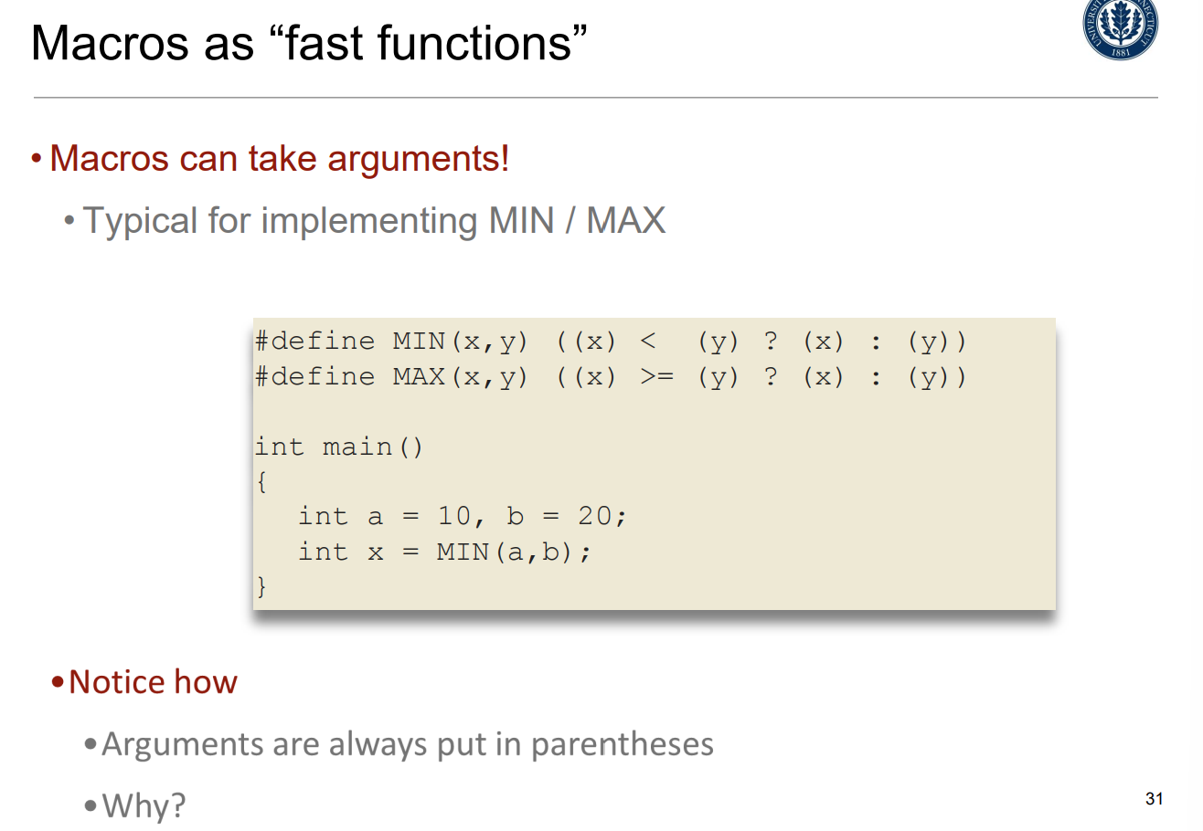

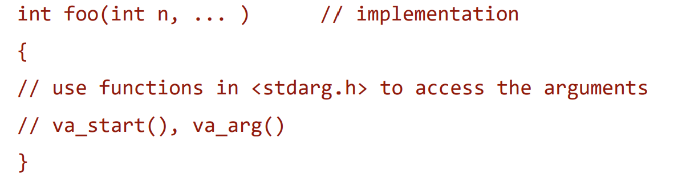

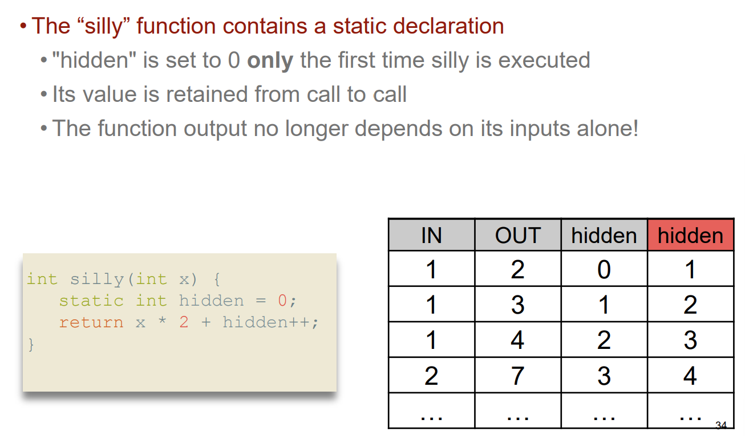

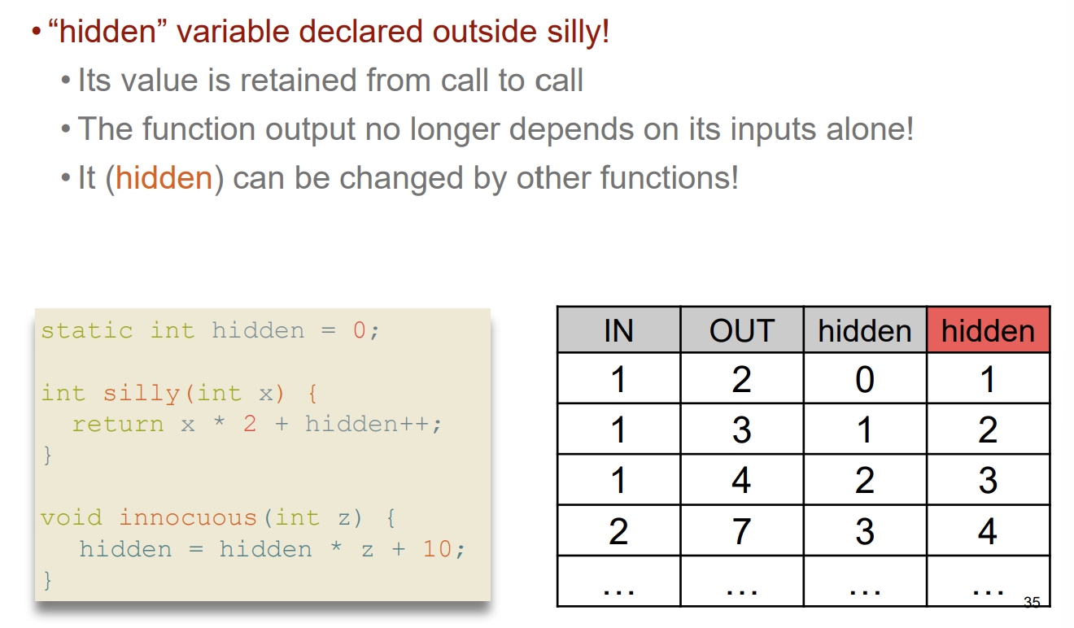

1/30 Functions are Fun